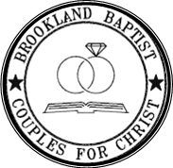
Couples Retreat 2022 – Frequently Asked Questions
Retreat Dates
The retreat has been scheduled for February 11 – 13, 2022.

Retreat Location
The site for Retreat 2022 will be the same, Rosen Shingle Creek Resort in Orlando.

Retreat Speakers
The speakers will be Rev. Reginald and Briana Sharpe of the Fellowship Missionary Baptist Church in Chicago, Illinois. They are excited to be with us as promised.

Additional Nights
The revised hotel contract will allow couples to schedule additional nights (for a rate of $159/night). Payment for additional nights will be due at check-in.

Registration at a later date
As long as there is space is available, couples can still register for Retreat 2022.

Retreat 2022 cancellations
The retreat cost is the same as Retreat 2021: $495 per couple.

Deadline for final payments
All retreat 2022 payments are due by September 2021. A revised payment schedule is attached.

Airline costs
Airline costs cannot be confirmed until closer to the Retreat 2022 date. We will continue to negotiate.

